LAB REPORT – 6
PART - 1
Decade Counter and 7-Segment Display

Name:Basireddy Khyathi Sri
Roll Number: 2023102065
Group Number: 6
Table : 3

Objective:
To obtain a 7 segment display counter, which counts up on
every ripple produced by 555 timer.

Electric Components Required:
- Arduino Uno
- IC 74HC93-Ripple counter
- 2 Resistors
- LED bulbs
- Breadboard
- Connecting wires
- CD4511 – 7 segment decoder
- 7 segment – display
- Power Supply
- Multimeter

The Reference Circuit:

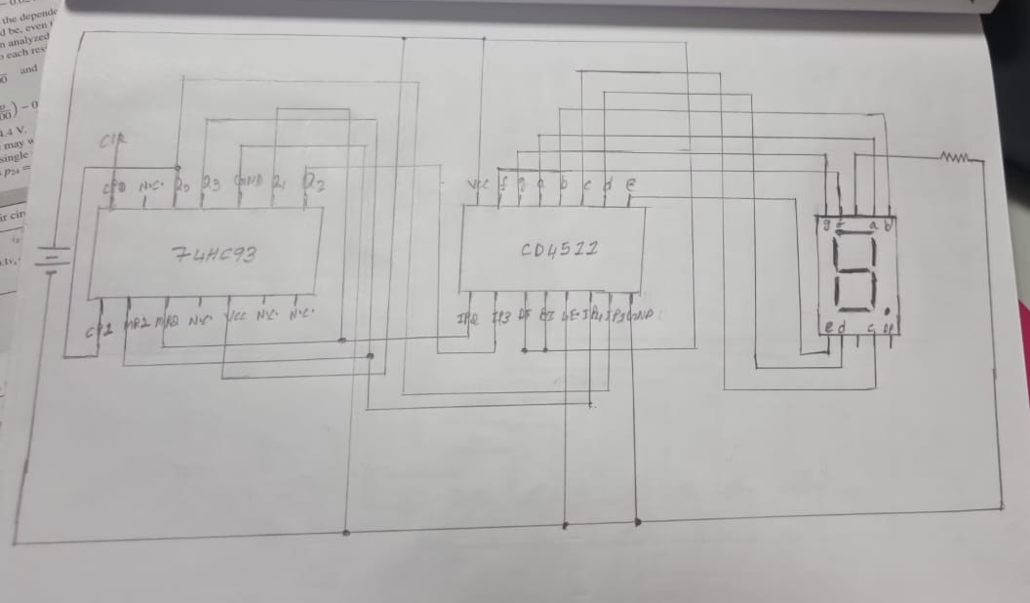

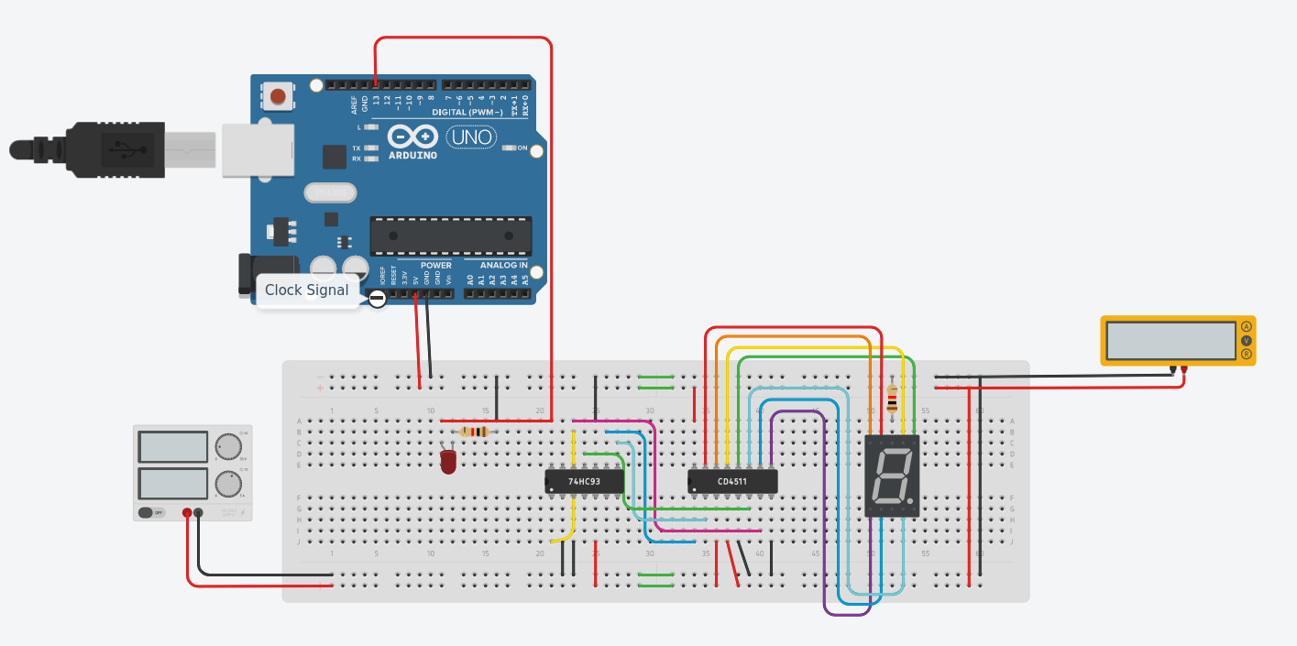

Procedure:

1. Connect an input pin from the arduino to the bulb and clock 0
( the link for the clock set up is given directly with t= 2 sec.
2. Connect the output of this timer to the Clock 0 of the ripple
counter IC.
3. Connect the output pins of the IC to the LEDs as shown.

Incrementing using ripple counter
1. Using the ripple counter IC, connect the outputs of the ripple
counter to the inputs of the segment decoder, manually
resetting the ripple counter when the output is Q1Q3 so that it
resets every time it reaches 10.
2. The outputs of the 7 segment – decoder are then connected to
the inputs of the 7 segment – display.
3. The output on the 7 segment – display is then obtained.

Code:
- // C++ code
- //
- int Clk_pin = 13;
- void setup()
- {
- pinMode(Clk_pin, OUTPUT);
- }

- void loop()
- {
- digitalWrite(Clk_pin, HIGH);
- delay(1000); // Wait for 1000 millisecond(s)
- digitalWrite(Clk_pin, LOW);
- delay(1000); // Wait for 1000 millisecond(s)
- }

Observations:
The output on the 7 segment – display is then observed, after
each pulse the output on it changes, which ranges from 0 to 9.

TinkerCad Simulation Link :
https://www.tinkercad.com/things/aN15GkfgZT7-decade-counter/editel?sharecode=pjC6qYfQgPrmksmWoy78dKEfup972pNxOnUHliUdAao

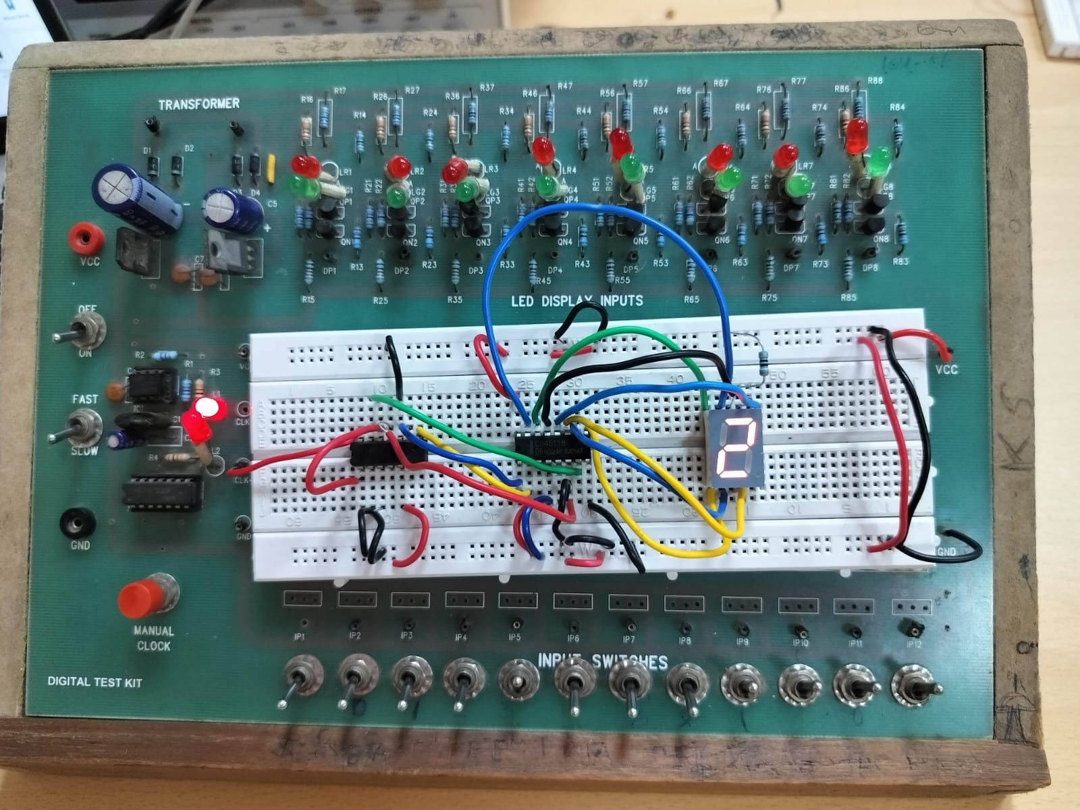

PART - 2(a)
0 to 255 counter using Shift Register

Objective:
Using the shift register IC and integrating it with Arduino and
write the code to count from 0 to 255 (using 8 LEDs in order).

Electric Components Required:
• Digital Test Kit (LED outputs)
• IC 74HC595 (shift register)
• Arduino UNO R3
• Connector for Arduino and PC

The Reference Circuit:

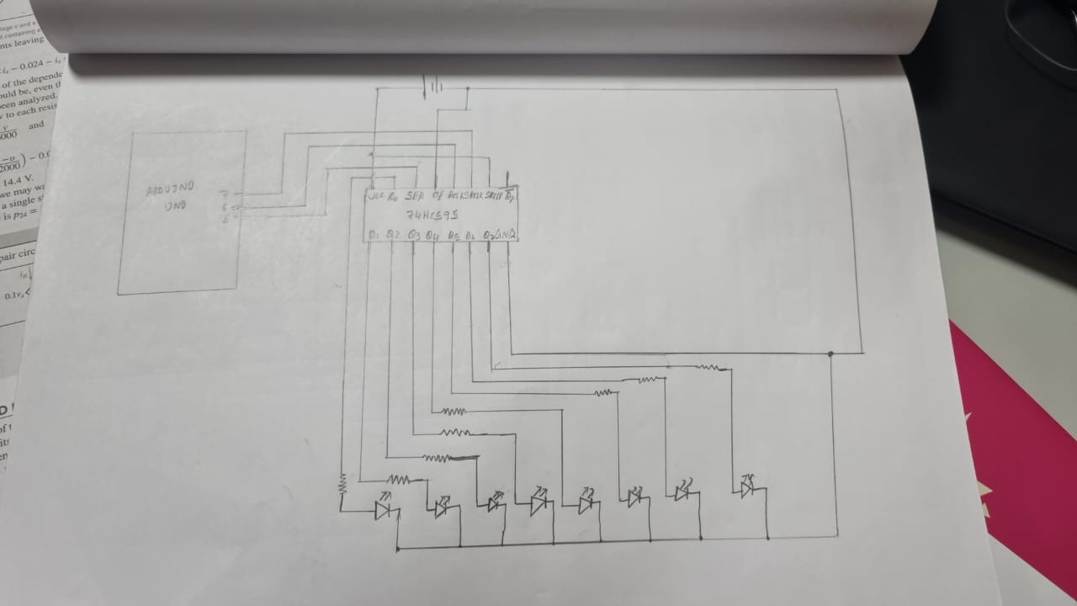

TinkerCad Simulation:

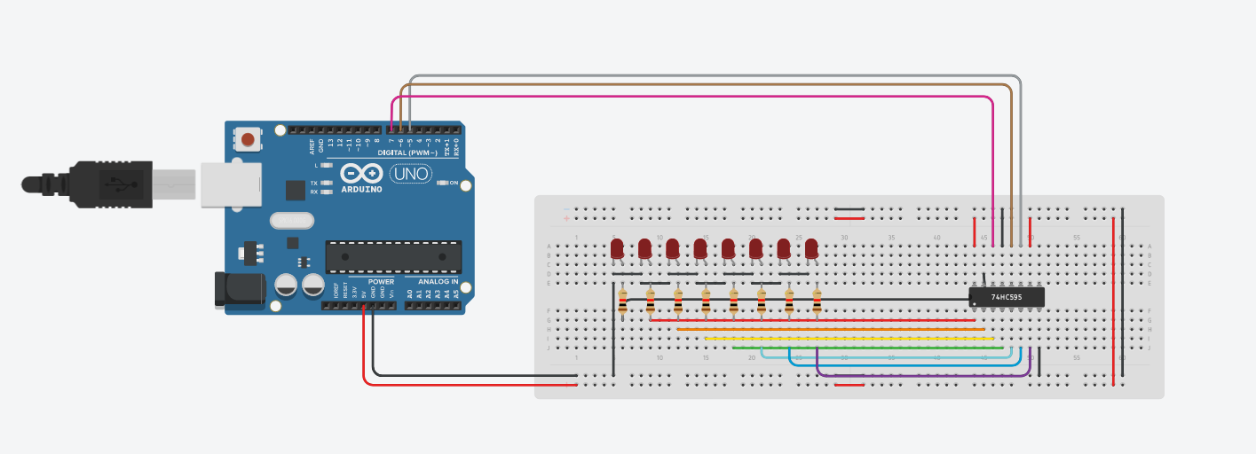
Procedure:
1. Connecting the breadboard's +/- columns to the Arduino's
5V / GND ports will power it up.
2. Put the 74HC595 shift register IC on a breadboard and turn it
on.
3. We must now supply the IC with three inputs from the
Arduino which are input, output register clock, and shift
register clock.
4. The code below is used with the Arduino IDE.

Code:
- int input = 7;
- int src = 5;
- int orc = 6;

- void setup(){
- pinMode(input, OUTPUT);
- pinMode(orc , OUTPUT);
- pinMode(src , OUTPUT);

- }void loop(){
- for(int i=0; i<256; i++){
- digitalWrite(orc, LOW);
- shiftOut(input, src, LSBFIRST, i);
- digitalWrite(orc, HIGH);
- delay(100);
- }
- }

5. The shiftOut() method is utilised here. It has four parameters:
two are pins (data pin and clock pin); one specifies the output
order (LSBFIRST); and one is the decimal representation of
the count, which is internally translated to binary.
6. We now set the output clock pin to LOW in an iteration. The
counter will then be increased using the shiftOut function.
Set the clock pin to HIGH after that.
7. Shift register clear (10) to VCC and the output enable (13) to
GND.
8. Finally, wire up each of the 8 outputs to a set of 8 LEDs in
sequence.

Observation:
We observe that the 8 LEDs counter starts from 0 and goes on
until 255 in the binary way.
Conclusion:
We have built a 0 to 255 counter using arduino and shift
register IC.

TinkerCad Simulation Link:

https://www.tinkercad.com/things/lFDRTvpp1wR-smashing-curcan-albar/editel?sharecode=MVS8BGV4H44tZASE2xwbie60rZAWg4iAYvzquGt-6cw

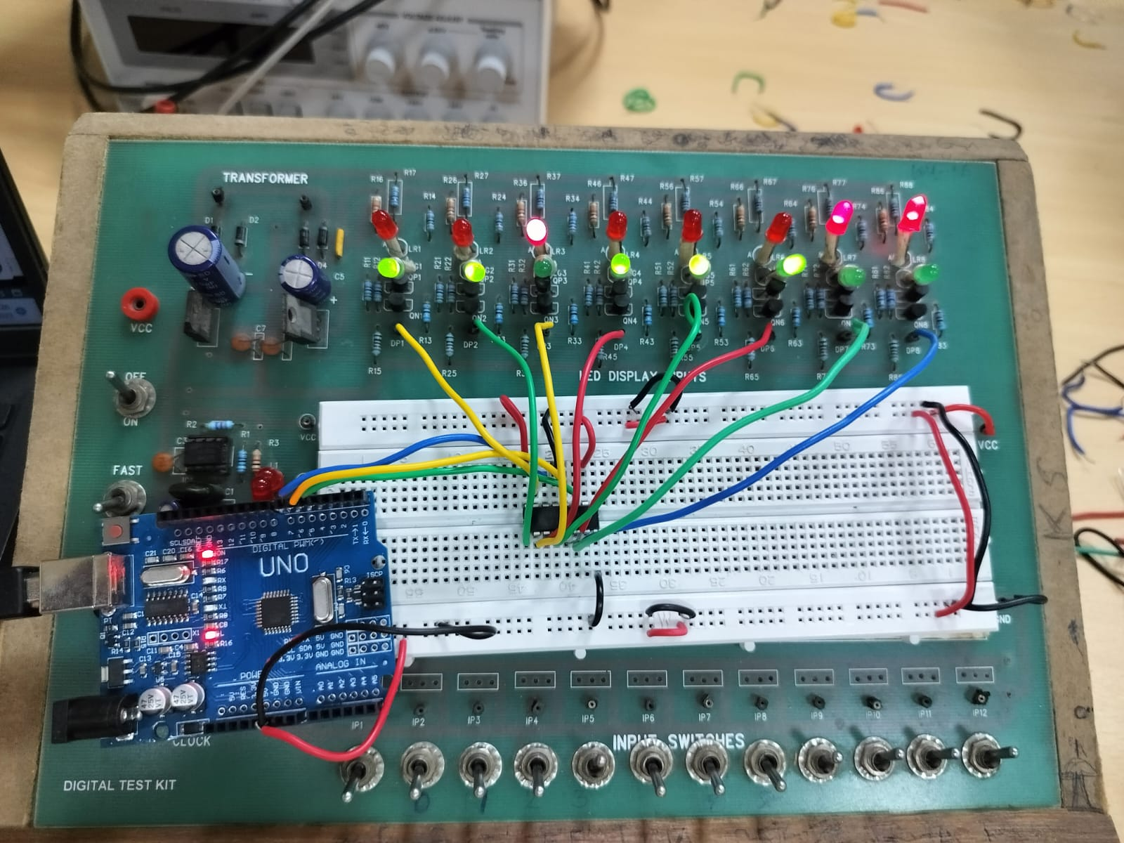

PART - 2(b)
0 t0 7 display using Shift Register

Objective:
Using the circuit made above write the code to take input
from the user (range 0-7) and glow the corresponding LED.

Electric Components Required:
• Digital Test Kit (LED outputs)
• IC 74HC595 (shift register)
• Arduino UNO R3
• Connector for Arduino and PC

The Reference Circuit:

Procedure:

1. The circuit does not need to be altered for this component.
All we have to do is modify the code.
2. Read the inputs using the Serial.read()-'0'
3. We use the shiftOut() function in this code as well, but the
fourth parameter is determined by user input.
4. shiftOut's fourth parameter has a decimal value. When the
count is a power of 2, just individual LEDs light.
5. So that the nth-LED lights up, we use the for loop for nth
power of 2.

Code:
- int input = 2;
- int src = 3;
- int orc =4;
- void setup(){
- Serial.begin(9600);
- pinMode(input, OUTPUT);
- pinMode(orc, OUTPUT);
- pinMode(src, OUTPUT);
- }
- void loop(){
- digitalWrite(orc, LOW);
- Serial.println("Enter the input between 0 to 7:");
- while(Serial.available()==0){}
- int ip = Serial.read()-'0';
- Serial.println(ip);
- Serial.println("\n");int num=1;
- for(int i=0; i<ip; i++)
- num*=2;
- shiftOut(input,src, LSBFIRST, num );
- digitalWrite(orc, HIGH);
- delay(1000);
- }

Observation:
We observe that when input (0-7) is given, the corresponding
bulb glows up, remaining stays at LOW.

TinkerCad Simulation Link:

https://www.tinkercad.com/things/7JhF1teoKNV-lab6-shift-register-0-7/editel?sharecode=WDgqbs5ImAHAl38E_y2tngpy6vpHZTJBciamUn2u6b8


